Practical Management System (PMS) Documentation

**[last modified : 17/11/2015]**

# User roles

1. Student
2. Tutor
3. Lecturer
4. AdminCumSuperUser
5. SystemAdmin

# Use Case Diagrams

1. Student Use Cases

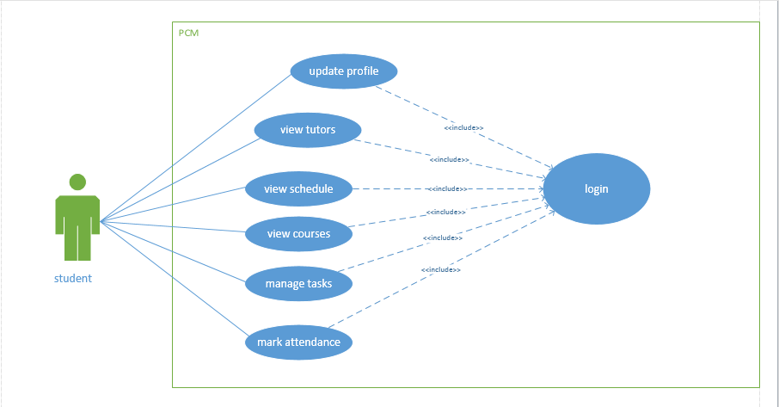

1. Tutor Use Cases

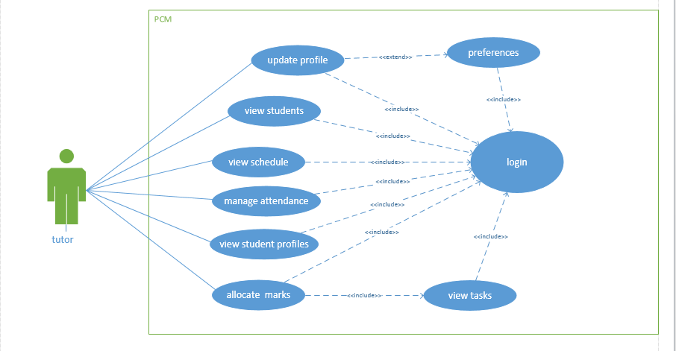

1. Lecturer Use Cases

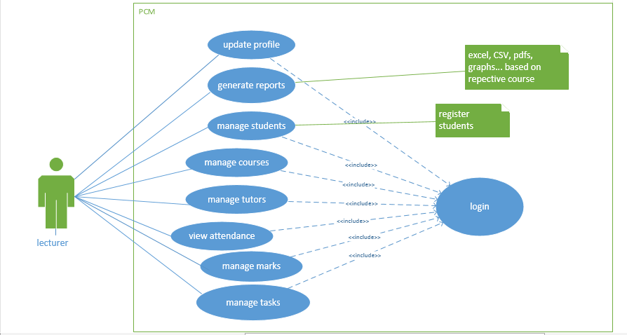

1. AdminCumSuperUser Use Cases

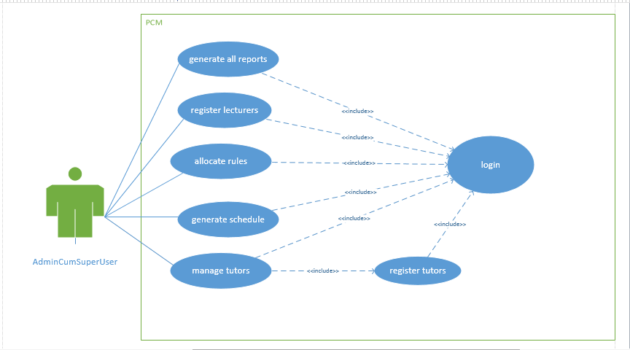

1. SystemAdmin Use Cases

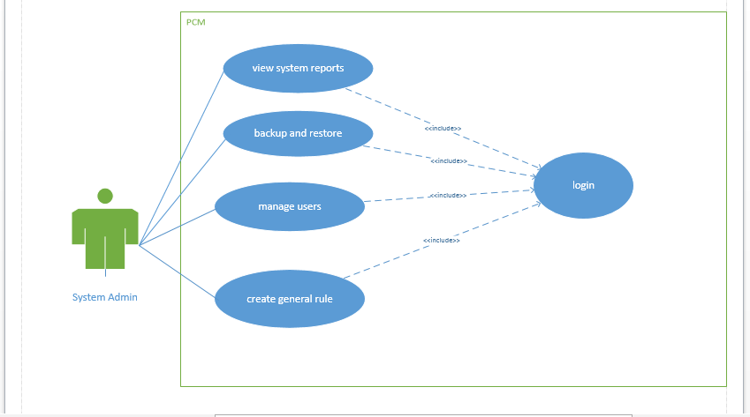

# Database Schema

PMS comprises of the following database tables

1. Students

|  |
| --- |
| **Students** |
| studentNumber  studentName  studentSurname  alternativeEmail  contactNumber  gender  address  image  dateOfBirth  degree |

1. Tutors

|  |
| --- |
| **Tutors** |
| tutorID  name  surname  alternativeEmail  contactNumber  gender  address  image  dateOfBirth  levelOfStudy  role (general, senior, HOT) |

1. Lectures

|  |
| --- |
| **Lecturers** |
| staffNumber  name  surname  title  alternativeEmail  contactNumber  officeNumber  gender  image |

1. Tasks

|  |
| --- |
| **Tasks** |
| taskID  taskName  taskID  taskDescription  file (file associated with task)  courseID |

1. Courses

|  |
| --- |
| **Courses** |
| courseID  courseName  courseDescription  duration (string – term 1,2,3…) |

1. AttendanceInfo

|  |
| --- |
| **AttendanceInfo** |
| attendanceID  date  time  taskID |

1. StudentAttendance

|  |
| --- |
| **StudentAttendance** |
| attendanceID  studentID |

1. TutorAttendance

|  |
| --- |
| **TutorAttendance** |
| attendanceID  tutorID |

1. Schedule

|  |
| --- |
| **Schedule** |
| tutorID  courseID  days (concatenated string – day1, day2, day3) |

1. Login

|  |
| --- |
| **Login** |
| userID  password  expirydate  role |

1. Rules

|  |
| --- |
| **Rules** |
| ruleID  ruleName  ruleDescription |

1. Preferences

|  |
| --- |
| **Preference** |
| tutorID  courseID1 (first preferred course)  courseID2  courseID3  day1 (first preferred day)  day2  day3 |

1. PracticalSessions

|  |
| --- |
| **PracticalSessions** |
| sessionID  courseID  studentID  tutorID |

1. TeachingAssignments

|  |
| --- |
| **TeachingAssignments** |
| staffID  courseID |